Athens Little League
Guidelines for Young Divisions
(Valley Rookies, Tee-Ball, Instructional)

Athens Little League Board Approved on March 4, 2018

Email:
athenspalittleleague18810@gmail.com

Facebook:
https://www.facebook.com/athenspalittleleague/

Website:
http://www.athenspalittleleague.org

Coordinator for Young Divisions:
Peggy Pelchy
ppelchy53109@yahoo.com
607-331-8005

Valley Rookies

Valley Rookies Specifics:
- Practice/Game Schedule
  - 1 weekday practice, head coach picks the day.
  - 1 weekend 2 inning game

- In-Game Rules
  - No live pitching is permitted, tee only.
  - Runners advance one base at a time.
  - Outs are not counted.
  - Team bats entire order, then sides switch.
  - Last batter runs a home-run and clears the bases.

Tee-Ball and Instructional
For Tee-Ball and Instructional
- Practice/Game Schedule
  - Suggested 2 practices per week during pre-season.
  - 1 practice per week during regular season.
  - Regular season consists of 1 or 2 games, weekdays and/or weekends, schedule is provided.
- The In-Game rules change at the half way point of the season, date to be determined by the coordinator.
- The positions shall be as shown in the photo below (assumes at least 10 players).
- If less than 10 players, a catcher shall not be used.
  - For Tee-Ball, the Catcher in stands back behind the coach assisting at home plate, to catch throws coming home. This player must wear a batting helmet.
  - For Instructional the Catcher wears full gear and plays the “real” position with coach backing up to speed up throwing back to the pitcher.
  - If teams have 11 players, a 5th outfielder shall be added to center field.
  - If there is a 12th player, a 2nd pitcher is added, one each side of the mound.
  - Players must be rotated through positions during the year to experience both infield and outfield, regardless of skill.

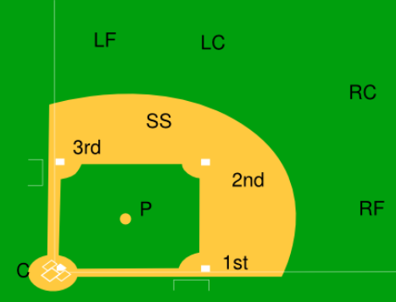

Tee-Ball Specifics:

- Suggested coaching guide:
  - https://www.littleleague.org/downloads/tee-ball-program/
- In-Game Rules
  - Entire Season
    - Runners can only advance one base at a time.
    - Outs are not counted.
    - Team bats entire order, then sides switch.
    - Last batter runs a home-run and clears the bases.
  - 1st half of the season:
    - Tee only
  - 2nd half of the season:
    - Coach pitch introduction
      - Coaches overhand pitch to all players, on one knee, from 35 feet (11 feet closer than the real mound)
      - Each batter gets 5 pitches. If the last pitch/swing is fouled, additional pitches will be granted. No limit on foul balls.
      - If the ball is not put in play within 5 pitches, a tee must be used.

Instructional (Coach-pitch) Specifics:

- Suggested coaching guide:
  - https://www.littleleague.org/downloads/coach-pitch-12-week-program/
- In-Game Rules
  - 1st half of the season:
    - Coaches overhand pitch to all players, on one knee, from 40 feet (6 feet closer than the real mound)
    - Each batter gets 5 pitches or 3 strikes. If the last pitch/swing is fouled, additional pitches will be granted. No limit on foul balls.
    - If batter doesn’t hit the ball in 5 pitches or 3 strikes then the batter hits off the tee.
    - Teams bat thru the whole order before switching sides. Last batter does not hit an automatic homerun, they advance one base.
    - Batter and runners are permitted to take one extra base if a ball is hit into the outfield to encourage runners following base coach’s signals
      - Runners cannot advance on overthrows
    - Runners leave the base paths if the opposing team gets them out.

  - 2nd half of the season:
    - Fielding outs are counted, teams switch sides after 3 outs or batting once through the order (whichever comes first).
    - There are no strike outs, but balls and strikes will be called to get players used to not swinging at everything.
- Learning Objectives
- Correct base running (rounding vs. running thru)
- Watching coaches when advancing bases
- Determining balls vs. strikes
- Correct positions on the field

Practice Locations

School Grounds
Lynch Bustin Elementary School, 253 Pennsylvania Ave, Athens, PA, United States
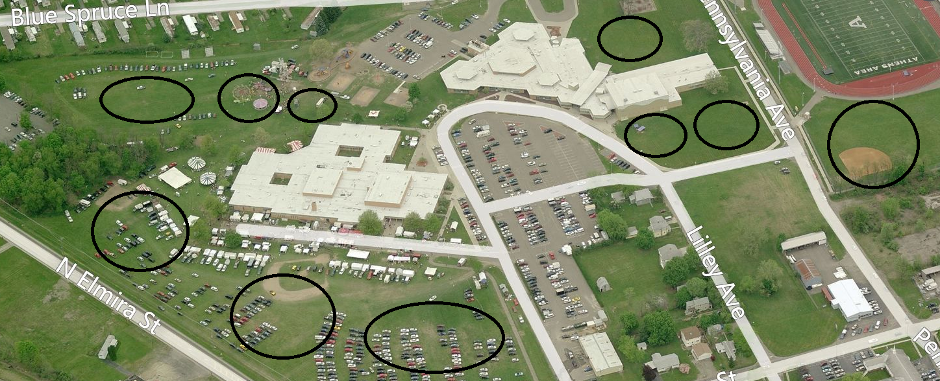

Valley Playland
Playland Dr, Athens, PA 18810
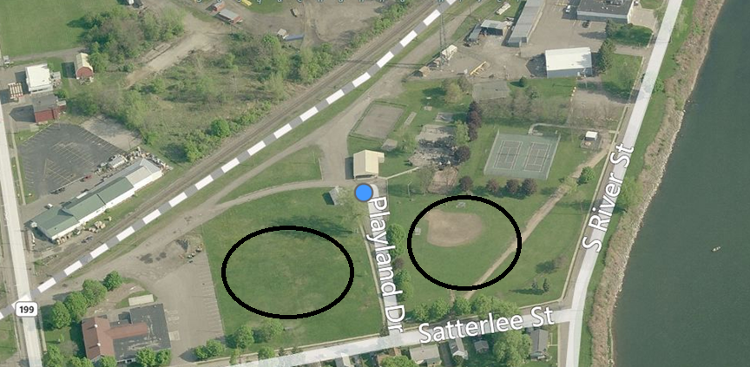

Across the River
Kirby St, Athens, PA 18810
